**HW1 Plots**

Wei (Will) Jiang

*\*All plots below are based on validation data*

**#Q3+Q4: Untransformed, Unstandardized Data**

Best k with RMSE: (12, 48933.22)

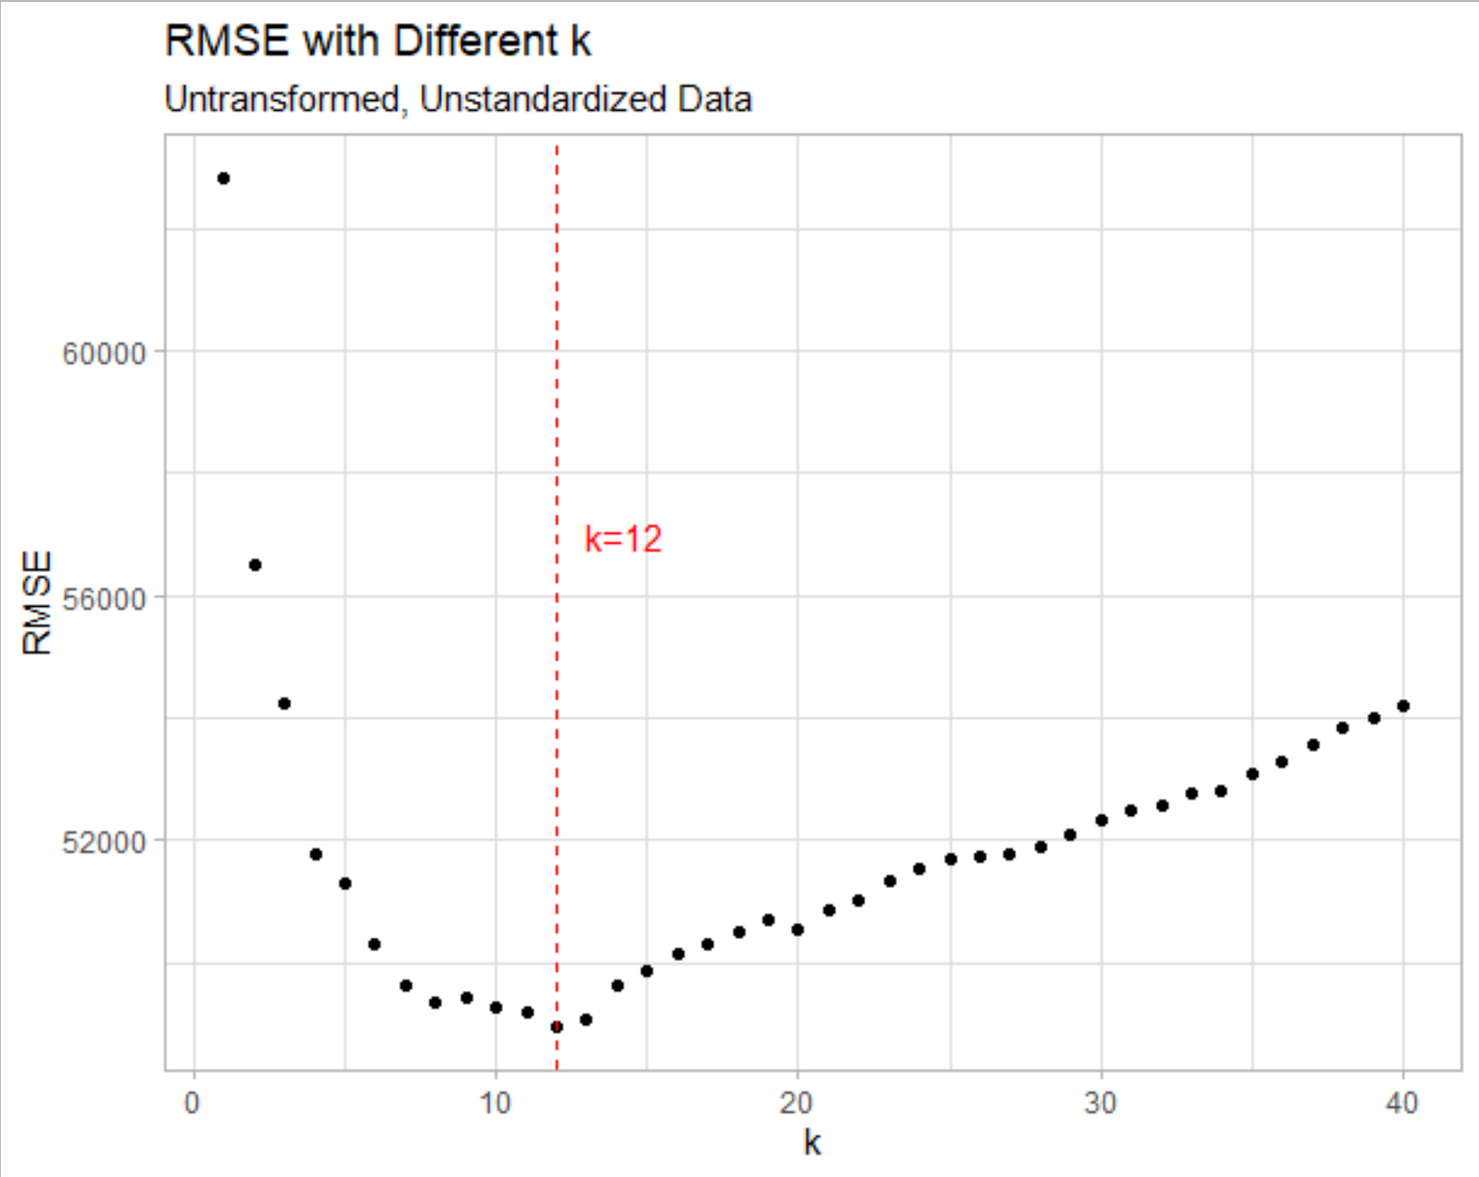

**#Q5+Q6: Untransformed, Standardized Data *(*BEST MODEL!)***

Best k with RMSE : (12, 39809.89)

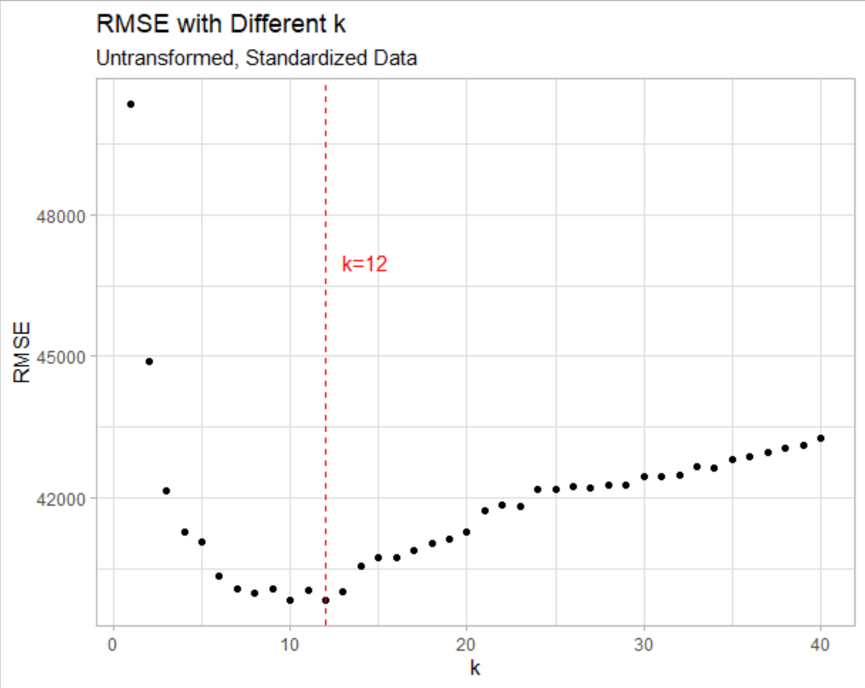

**#Q7+Q8: Transformed, Unstandardized Data**

Best k with RMSE : (2, 53278.00)

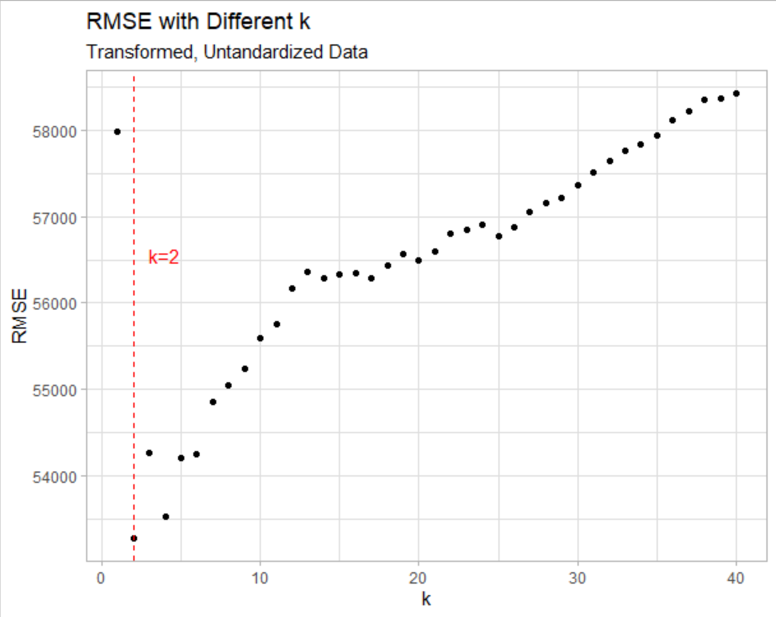

**#Q9+Q10: Transformed, Standardized Data**

Best k with RMSE : (10, 41776.35)

